**logos**

1. **whatsapp**
2. **air Canada(airline)**
3. ** air new zeland (airline)**
4. **oceanic airlines**
5. ** srilankan airlines**
6. ** Baoding dadi (car)**
7. 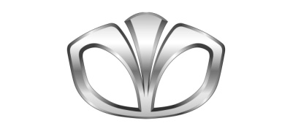**Daewoo**
8. 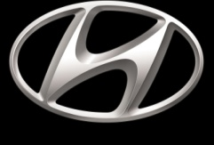 **Hyundai**
9. 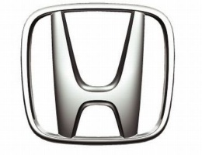 **Honda cars**
10. 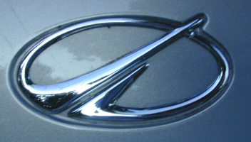 **oldsomobile(car)**
11. **Perodua(car)**
12. 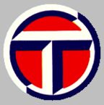 **Talbot(car)**
13. 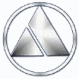 **Autobianchi(car)**
14. ** Microsoft office 2010**
15. ** Kaspersky (antivirus)**
16. ** Hindustan unilever**
17. ** sonata arctica**
18. **masterchef**
19. ** ICBC**
20. 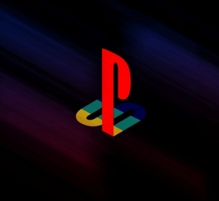 **playstation**
21. 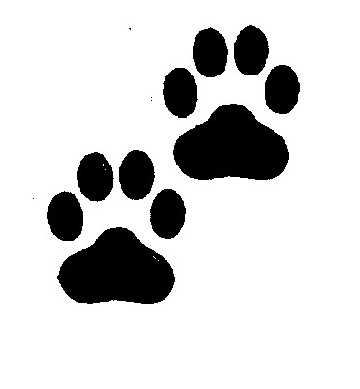 **Pugmarks**
22. 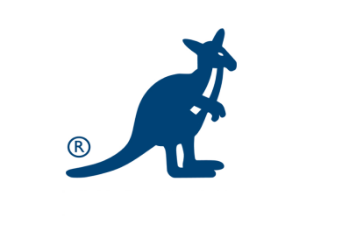 **kangol**  (**Kangol** is a clothing company famous for its headwear)
23.  **Red hat** (The **Red Hat Certification Program** is [Red Hat](http://en.wikipedia.org/wiki/Red_Hat)'s [professional certification](http://en.wikipedia.org/wiki/Professional_certification) program for Red Hat and general Linux related skills such as [system administration](http://en.wikipedia.org/wiki/System_administration) on [Red Hat Enterprise Linux](http://en.wikipedia.org/wiki/Red_Hat_Enterprise_Linux).)
24.  **Sunmicrosystems**
25. ** westjet airlines**
26. 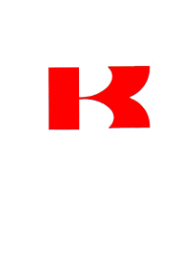**Kawasaki**
27. **puma**
28. 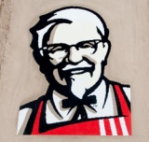 **kfc**
29. ** blogger**
30. ** macfree antivirus**
31. ** Ubisoft Entertainment (**is a French global video game publisher and developer, with headquarters in Rennes, France.)
32.  **sunsilk**